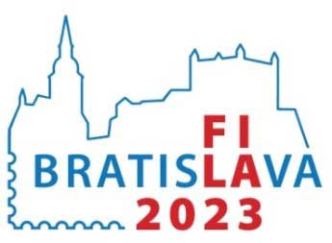
NATIONAL
PHILATELIC EXHIBITION
WITH INTERNATIONAL PARTICIPATION

Exhibit Application
(Literature)
Name and surname:
Postal address: |  |  |  | Country:
Email address: |  |  |  | Phone/Mobile:
Title and subtitle:
Author(s):
Printer / Publisher:
Year of issue: |  | Language: |  |  | ISBN/ISSN:
Number of pages: |  | Format: |  |  | Binding:
Periodicity (only for periodicals)?
Short description of the exhibit:
The exhibitor hereby confirms the correctness of the given data and agrees to provide personal data solely for the needs of the exhibition's organizational committee and the exhibition jury.

Date and signature of the exhibitor:
The national federation (or national commissionaire if appointed) hereby confirms exhibitor´s membership and correctness of the application data:

Date and signature of the authority:
Please send the application by January 31, 2023 to: Secretary ZSF, Radlinskeho 9, 812 11 Bratislava, Slovakia

