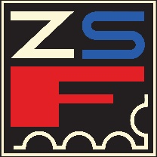
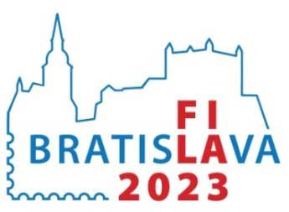
NATIONAL
PHILATELIC EXHIBITION
WITH INTERNATIONAL PARTICIPATION

Exhibit Application
(Adult exhibitor)
Name and surname:
Postal address: |  |  |  |  | Country:
Email address: |  |  |  |  | Phone/Mobile:
Exhibit title:
Exhibit class: |  | No. of frames: |  |  | Value:
Short description of the exhibit:
Recent awards received
Exhibition |  | Exhibition level |  | Medal |  | Number of points
Exhibit will be delivered to the exhibition: □ personally, □ by the national commissionaire, □ by post
Exhibit will be taken from the exhibition: □ personally, □ by the national commissionaire, □ by post
The exhibitor hereby confirms the correctness of the given data and agrees to provide personal data solely for the needs of the exhibition's organizational committee and the exhibition jury.

Date and signature of the exhibitor:
The national federation (or national commissionaire if appointed) hereby confirms exhibitor´s membership and correctness of the application data:

Date and signature of the authority:
Please send the application by January 31, 2023 to: Secretary ZSF, Radlinskeho 9, 812 11 Bratislava, Slovakia

